COMMUNITY NOTICEBOARD
@CREATIVITY THINK (9483175986/7019689991)

ABSTRACT:
Community Noticeboard is a web-based platform designed to centralize announcements, notices, events, and information sharing within residential communities, public areas, and social groups. The system enables users to post notices, tag locations, attach files, and interact through comments, while administrators moderate posts, manage users, and oversee community activities through a dashboard. Developed using Django and Django Rest Framework on the backend, paired with React, axios, and recharts on the frontend, this platform ensures organized communication, enhanced transparency, and streamlined information flow in apartments, societies, and public communities..

INTRODUCTION OF THE PROJECT:
In residential societies, apartments, and community areas, notice dissemination often relies on outdated physical boards or scattered communication channels such as WhatsApp groups, emails, or printed circulars. These methods lack structure, moderation, and proper tracking of notices. The Community Noticeboard system fills this gap by offering a centralized, digital platform where users can post, comment, attach files, and tag locations while administrators maintain control over content approval and user management. The automated workflows ensure smoother communication and improved engagement across community members..

PROJECT OBJECTIVES:

• Provide a centralized online board for posting community notices
• Allow users to attach files, images, and location tags to notices
• Enable commenting and real-time engagement on posts
• Allow administrators to approve, reject, or remove notices
• Provide structured dashboards for activity analytics
• Ensure efficient moderation of users and content
• Support tagging of places, blocks, or society areas
• Improve transparency, communication, and community participation

PROBLEM OF THE STATEMENT:
Traditional noticeboard systems used in residential communities and public places lack accessibility, real-time updating, and user engagement. Physical boards cannot host comments, attachments, or location-based notices, and digital group chats are cluttered and lack moderation. This results in miscommunication, delayed updates, and disorganized information flow. The Community Noticeboard system solves these problems by introducing a structured online platform with controlled posting, real-time interactions, analytics, and administrative oversight..

MOTIVATION OF THE PROJECT:
• To digitalize and modernize community communication
• To eliminate cluttered message groups and outdated physical boards
• To provide a transparent and moderated notice-posting environment
• To enable residents and community members to engage actively
• To support essential features like comments, attachments, and tagging
• To offer administrators better control and oversight
• To promote organized, clean, and real-time notice sharing

BLOCK DAIGRAM OF PROJECT:

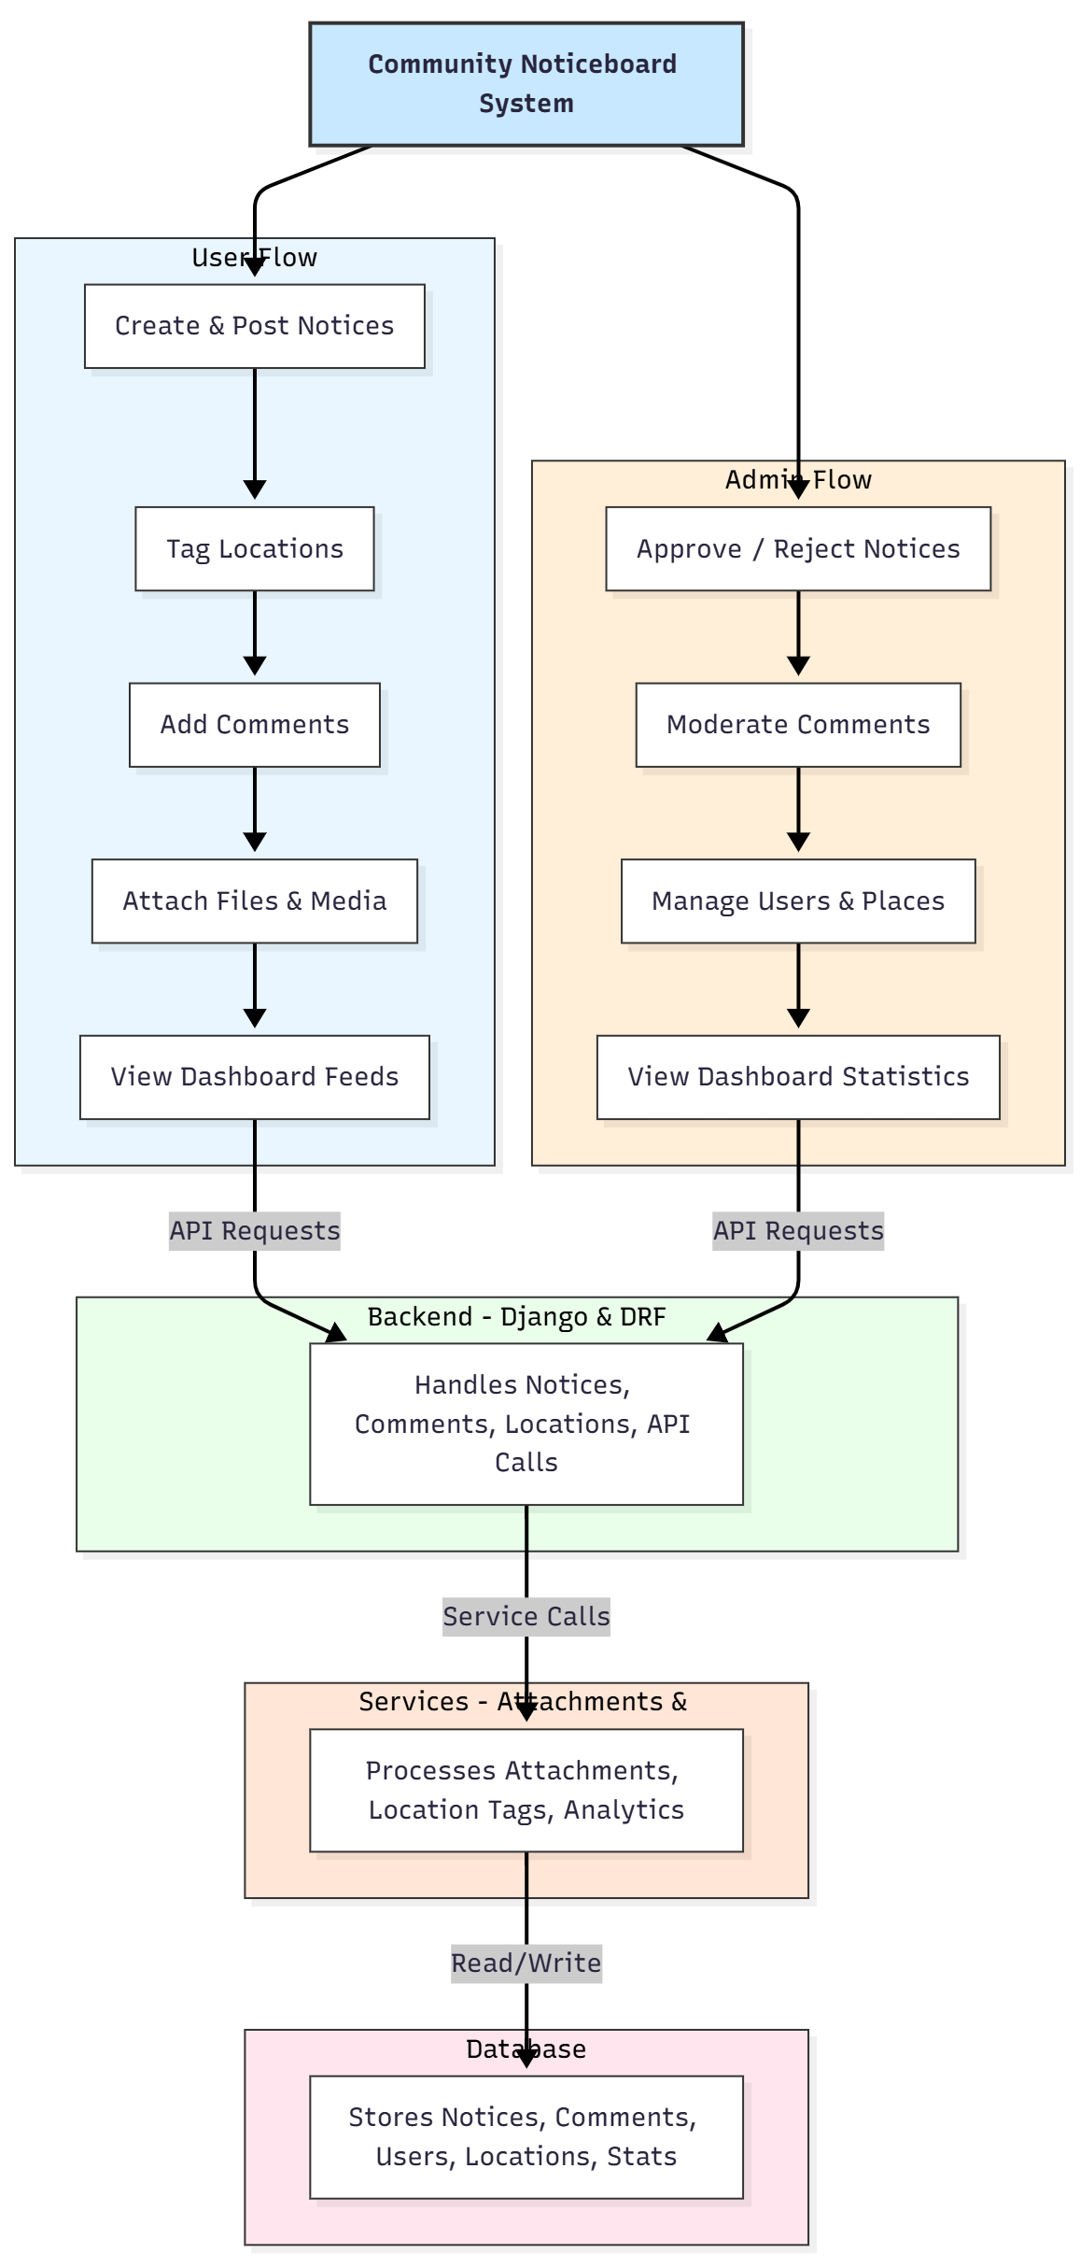

WORKING OF THE PROJECT:
Users begin by creating a notice and attaching details such as text, images, documents, or location tags. The notice is then sent for approval to the admin. Administrators review the content and approve or reject it based on community guidelines. Once approved, notices appear on the dashboard feed, where users can engage by commenting or viewing attachments. The backend processes all submissions, comments, and location data, while the services module manages attachment processing and analytics. The dashboard provides graphical insights into notice activity, user participation, and engagement trends. All data is stored securely in the database for moderation and reporting..

SOFTWARE REQUIREMENT:
- Backend:
  - Python 3.x
  - Django
  - Django REST Framework
  - SQLite/PostgreSQL
- Frontend:
  - Node.js and npm
  - React.js
  - Axios
- Development Tools:
  - Visual Studio Code
  - Postman (for testing APIs)
  - Git/GitHub (for version control)
- Server/Deployment (Optional):
  - Gunicorn, Nginx, or Heroku/AWS for hosting

ADVANTAGES OF THE PROJECT:

• Centralized digital noticeboard for communities
• Real-time updates and instant notice availability
• Attachment and location tagging support
• User engagement through comments
• Strong moderation control for administrators
• Dashboard analytics for activity tracking
• Eliminates confusion from outdated physical boards
• Improves transparency and communication

APPLICATIONS OF THE PROJECT:
• Apartments and gated societies
• Public community centers
• Residential colonies
• College and school campuses
• Local administrative bodies
• Office premises notice systems

REFERENCES:

- Django REST Framework Documentation — Django Software Foundation. Django Documentation. Available: https://docs.djangoproject.com/
- Django REST Framework. DRF Documentation. Available: https://www.django-rest-framework.org/
- React. React Official Documentation. Available: https://reactjs.org/docs/getting-started.html
- Redux. Redux Documentation. Available: https://redux.js.org/introduction/getting-started
- PostgreSQL Global Development Group. PostgreSQL Documentation. Available: https://www.postgresql.org/docs/
- MySQL. MySQL Reference Manual. Available: https://dev.mysql.com/doc/
- Git. Git Documentation. Available: https://git-scm.com/doc
- Node.js. Node.js Documentation. Available: https://nodejs.org/en/docs/
- Axios. Axios Documentation. Available: https://axios-http.com/docs/intro
- Socket.io Documentation – https://socket.io/docs/

